**JavaScript Basics –**

**1. use of var**

var a=1

var b=2

var c=a+b

console.log(c)

**output:**

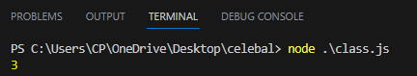

**2. use of let**

let x=1

let y=3

let z=x+y

console.log(x,y,z)

**output:**

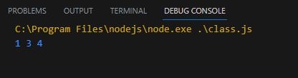

**3. use of const**

const x=3

const y=2

const z=x+y

console.log(x,y,z)

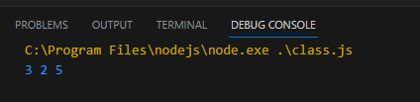

**4. example of if we declare a variable with same name using let it will give an error but if we use var it will not give an error.**

var city = "jaipur";

var city = "delhi";

console.log(city)

**output:**

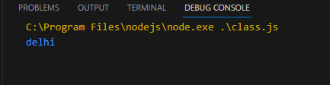

var let = "jaipur";

var let = "delhi";

console.log(city)

**Output:**

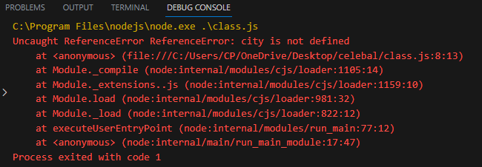

**5. if we use a function let will not give an error in this situation because of the scope of global and local variable.**

let country="india"

function fun(){

    let country="china"

}

**Output:**

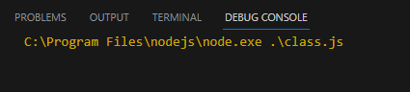

**6. Airthmetc , Assignment , comparision , logical operators.**

let x = 5+5

let y = 10-5

let w = x*y

console.log(w)

//Assignment

let a=1

let b=0

b+=a

console.log(b)

//comparision

if(a==b){

    console.log("true")

}

else{

   console.log("false")

}

//logical

console.log(5=='5'&&4==4)

console.log(5==='5'&&4==4)

**output:**

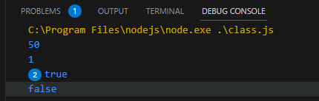

**7. String operator**

let temp = 'i am temp1'

let temp2='i am temp 2'

console.log(temp+temp2)

**output:**

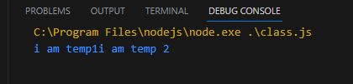

**Data types :**

**1. Primitive 2. Composite 3. special**

**8. primitive data types**

let age= 25

let name1='jhon'

let isindian = false

let person={

    name1:'jhon',

    age:25,

    isindian:false,

}

console.log(typeof(age))

console.log(typeof(name1))

console.log(typeof(isindian))

**output:**

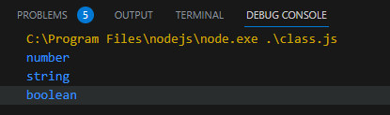

**9. switch case when there is no break it will print all.**

let value="0"

switch(value){

    case "0":

        console.log('zero')

    case "0":

        console.log('one')

}

**Output:**

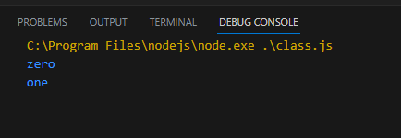

**10. Loops (For Loop(use for keys))**

const person={

    fname:'jhon',

    name:'doe',

    age:25,

}

for(let x in person){

    console.log(x,':',person[x])

    }

**Output:**

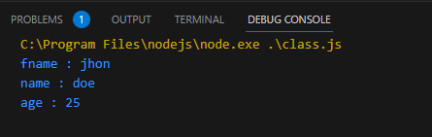

**11. for of loop (use for values)**

const cars=["bmw","volvo"]

let data=" "

for(let x of cars){

    data+=x

    }

    console.log(data)

**output:**

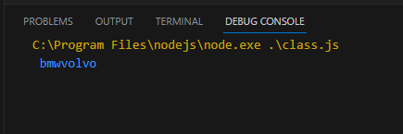

**For each loop**

let students = ['John', 'Sara', 'Jack'];

// using forEach

students.forEach(myFunction);

function myFunction(item) {

    console.log(item);

}

**Output:**

